Example of Tuning Cube II
Date: Dicember 2016
Author: Ramón Portolés, Alberto Linkedin

The tunning process has been
- Hive Input tables compressed
- HBase Output compressed
- Apply techniques of reduction of cardinality (Joint, Derived, Hierarchy and Mandatory)
- Personalize Dim encoder for each Dim and choose the best order of Dim in Row Key

Now, there are three types of cubes:
- Cubes with low cardinality in their dimensions (Like cube 4, most of time is usend in flat table steps)
- Cubes with high cardinality in their dimensions (Like cube 6,most of time is usend on Build cube, the flat table steps are lower than 10%)
- The third type, ultra high cardinality (UHC) which is outside the scope of this article

Cubes 6: Cube with high cardinality Dimensions
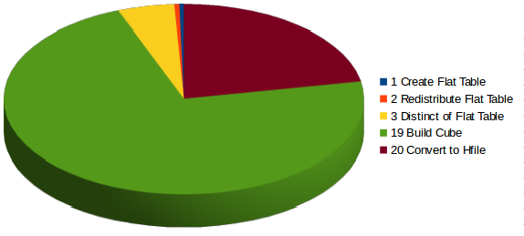
In this case 72% of the time is used to build Cube
This step is a MapReduce task, you can see the Sql Hive of these steps on >

How can the performance of Map – Reduce be improved? The easy way is to increase the numbers of Mappers and Reduces (= Increase parallelism).
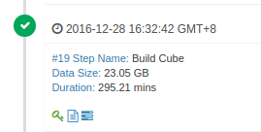
NOTE: YARN / MapReduce have a lot parameters to configure and adapt to the system. The focus here is only on small parts.
(In my system I can assign 12 – 14 GB and 8 cores to YARN Resources):
yarn.nodemanager.resource.memory-mb = 15 GB
- yarn.scheduler.maximum-allocation-mb = 8 GB
- yarn.nodemanager.resource.cpu-vcores = 8 cores
With this config our max theoretical grade of parallelism is 8. However, this has a problem: “Timed out after 3600 secs”

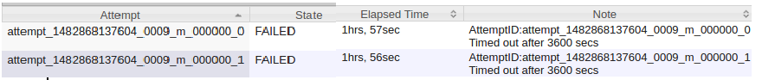
The parameter mapreduce.task.timeout (1 hour by default) define max time that Application Master (AM) can happen with out ACK of Yarn Container. Once this time passes, AM kill the container and retry the same 4 times (with the same result)
Where is the problem? The problem is that 4 mappers started, but each mapper needed more than 4 GB to finish
- The solution 1: add more RAM to YARN
- The solution 2: increase vCores number used in Mapper step to reduce the RAM used
- The solution 3: You can play with max RAM to YARN by node (yarn.nodemanager.resource.memory-mb) and experiment with min RAM per container (yarn.scheduler.minimum-allocation-mb). If you increase minimum RAM per container, YARN will reduce the numbers of Mappers

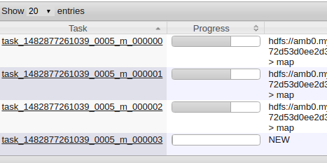
In the last two cases the result is the same: reduce the level of parallelism ==>
- Now 3 mappers start at the same time, the fourth must wait for a free slot
- The three first mappers distribute the ram among themselves, and as a result they will have enough ram to finish the task

During a normal “Build Cube” step you will see similar messages on YARN log:
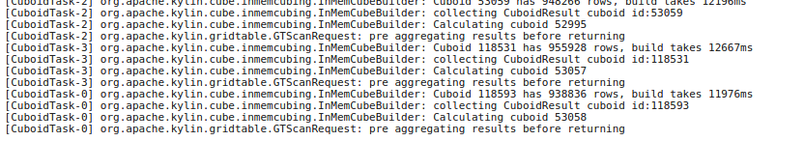
If you don’t see this periodically, perhaps you have a bottleneck in the memory

Cube 7: Improve cube response time
We can try to use different aggregation groups to improve the query performance of some very important Dim or a Dim with high cardinality.
In our case we define 3 Aggregation Groups:
- “Normal cube”
- Cube with Date Dim and Currency (as mandatory)
- Cube with Date Dim and Carteras_Desc (as mandatory)
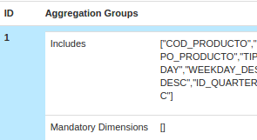
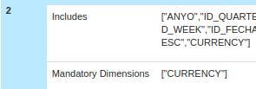
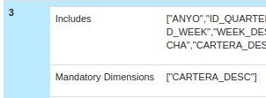

Compare without / with AGGs:
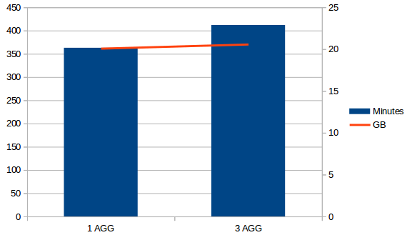
Now it uses 3% more time to build the cube and 0.6% of space, but queries by currency or Carteras_Desc will be much faster.

